What is a Project?
A project is “a temporary effort undertaken to create a unique product, service, or result” (PMBOK® Guide, Fifth Edition, 2012)
Operations is work done to sustain the business
Projects end when their objectives have been reached or the project has been terminated
Projects can be large or small and take a short or long time to complete
A task is more ‘project-like’ if it is:
- Non-routine
- Planned
- Aiming at a specific target
- Work carried out for a customer
- Involving several specialisms
- Made up of several different phases
- Constrained by time and resources
- Large and/or complex

Project Management Statistics
- The overall information and communications technology market grew by 6 percent to almost $3 trillion in 2010
- In the U.S. the size of the IT workforce topped 4 million workers in 2008, and the unemployment rate for IT professionals is half the rate for the overall labor market
- In 2011 the total compensation for the average senior project manager in U.S. dollars was $105,000 per year in the United States and $160,409 in the Switzerland.
- The number of people earning their Project Management Professional (PMP) certification continues to increase. 44 percent of employers listed project management as a skill they looked for in new college grads, behind only communication and technical skills
Motivation for Studying Information Technology (IT) Project Management
- IT Projects have a terrible track record, as described in the What Went Wrong?
- A 1995 Standish Group study (CHAOS) found that only 16.2% of IT projects were successful in meeting scope, time, and cost goals; over 31% of IT projects were canceled before completion
- A PricewaterhouseCoopers study found that overall half of all projects fail and only 2.5% of corporations consistently meet their targets for scope, time, and cost goals for all types of project.
Examples of IT Projects
- A team of students creates a smartphone application and sells it online
- A company develops a driverless car
- A small software development team adds a new feature to an internal software application for the finance department
- A college upgrades its technology infrastructure to provide wireless Internet access across the whole campus
Project Attributes
A project
  - has a unique purpose
  - is temporary
  - is developed using progressive elaboration
  - requires resources, often from various areas
  - should have a primary customer or sponsor
    - The project sponsor usually provides the direction and funding for the project
  - involves uncertainty
What is Project Management?
- Project management is “the application of knowledge, skills, tools and techniques to project activities to meet project requirements” (PMBOK® Guide, Fourth Edition, 2012)
- Project managers strive to meet the triple constraint (project scope, time, and cost goals) and also facilitate the entire process to meet the needs and expectations of project stakeholders
OR
Project management is the discipline of initiating, planning, executing, controlling, and closing the work of a team to achieve specific goals and meet specific success criteria within a defined scope, schedule, and cost.
Project Management Tools and Techniques
- Project management tools and techniques assist project managers and their teams in various aspects of project management
- Some specific ones include
  - Project charter, scope statement, and WBS (scope)
  - Gantt charts, network diagrams, critical path analysis, critical chain scheduling (time)
  - Cost estimates and earned value management (cost)
- “Super tools” are those tools that have high use and high potential for improving project success, such as:
  - Software for task scheduling (such as project management software)
  - Scope statements
  - Requirements analyses
  - Lessons-learned reports
- Tools already extensively used that have been found to improve project importance include:
  - Progress reports
  - Kick-off meetings
  - Gantt charts
  - Change requests
Why the Improvements?
"The reasons for the increase in successful projects vary. First, the average cost of a project has been more than cut in half. Better tools have been created to monitor and control progress and better skilled project managers with better management processes are being used. The fact that there are processes is significant in itself.”*
*Standish Group, "CHAOS 2001: A Recipe for Success" (2001).
Project Success
- There are several ways to define project success:
  - The project met scope, time, and cost goals
  - The project satisfied the customer/sponsor
  - The results of the project met its main objective, such as making or saving a certain amount of money, providing a good return on investment, or simply making the sponsors happy
What Helps Projects Succeed?*
1. User involvement
2. Executive support
3. Clear business objectives
4. Emotional maturity
5. Optimizing scope
6. Agile process
7. Project management expertise
8. Skilled resources
9. Execution
10. Tools and infrastructure
Project Management Framework / 10 Project Management Knowledge Areas
- Knowledge areas describe the key competencies that project managers must develop
- Project managers must have knowledge and skills in all 10 knowledge areas (project integration, scope, time, cost, quality, human resource, communications, risk, procurement, and stakeholder management)
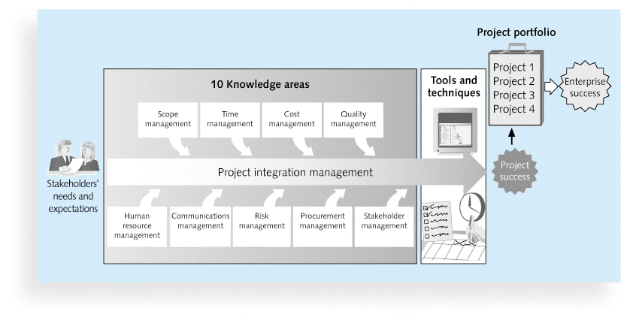

Real-World Example:
- Building a New Bridge: This project involves planning, designing, resource allocation, construction, testing, and finally, opening the bridge to traffic.
- Building a new software: A software for customer relationship management (CRM) in a company. The project manager needs to manage developers, set timelines, and ensure the software meets user requirements without exceeding budget.
Project and Program Managers
- Project managers work with project sponsors, project team, and other people involved in a project to meet project goals
- Program: group of related projects managed in a coordinated way to obtain benefits and control not available from managing them individually (PMBOK® Guide, Fifth Edition, 2012)
- Program managers oversee programs; often act as bosses for project managers
Program and Project Portfolio Management
- A program is “a group of related projects managed in a coordinated way to obtain benefits and control not available from managing them individually” (PMBOK® Guide, Fifth Edition, 2012)
- A program manager provides leadership and direction for the project managers heading the projects within the program
- Examples of common programs in the IT field include infrastructure, applications development, and user support
Project Portfolio Management
- As part of project portfolio management, organizations group and manage projects and programs as a portfolio of investments that contribute to the entire enterprise’s success
- Portfolio managers help their organizations make wise investment decisions by helping to select and analyze projects from a strategic perspective
- Organizations group and manage projects and programs as a portfolio of investments that contribute to the entire enterprise’s success
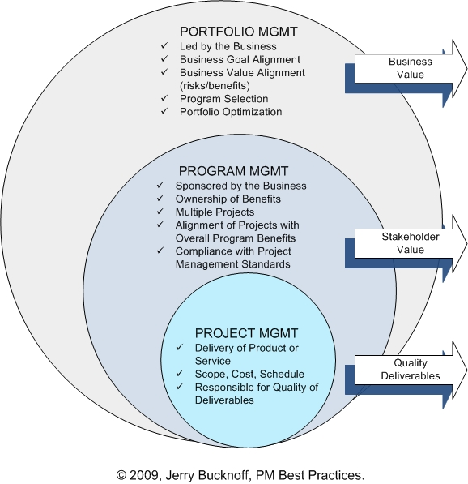
Figure 1-3. Project Management Compared to Project Portfolio Management

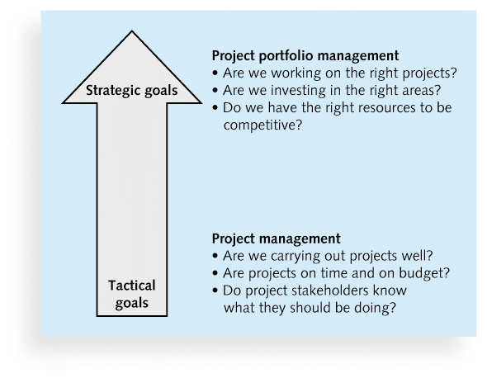
Best Practice
- A best practice is “an optimal way recognized by industry to achieve a stated goal or objective”*
- Robert Butrick suggests that organizations need to follow basic principles of project management, including these two mentioned earlier in this chapter:
  - Make sure your projects are driven by your strategy. Be able to demonstrate how each project you undertake fits your business strategy, and screen out unwanted projects as soon as possible
  - Engage your stakeholders. Ignoring stakeholders often leads to project failure. Be sure to engage stakeholders at all stages of a project, and encourage teamwork and commitment at all times

The Role of the Project Manager
- Job descriptions vary, but most include responsibilities like planning, scheduling, coordinating, and working with people to achieve project goals
- Remember that 97% of successful projects were led by experienced project managers, who can often help influence success factors
Suggested Skills for Project Managers

- The Project Management Body of Knowledge
- Application area knowledge, standards, and regulations
- Project environment knowledge
- General management knowledge and skills
- Soft skills or human relations skills
Ten Most Important Skills and Competencies for Project Managers
1. People skills
2. Leadership
3. Listening
4. Integrity, ethical behavior, consistent
5. Strong at building trust
6. Verbal communication
7. Strong at building teams
8. Conflict resolution, conflict management
9. Critical thinking, problem solving
10. Understands, balances priorities
Different Skills Needed in Different Situations
- Large projects: Leadership, relevant prior experience, planning, people skills, verbal communication, and team-building skills were most important
- High uncertainty projects: Risk management, expectation management, leadership, people skills, and planning skills were most important
- Very novel projects: Leadership, people skills, having vision and goals, self confidence, expectations management, and listening skills were most important
Importance of Leadership Skills
- Effective project managers provide leadership by example
- A leader focuses on long-term goals and big-picture objectives while inspiring people to reach those goals
- A manager deals with the day-to-day details of meeting specific goals
- Project managers often take on the role of both leader and manager
Careers for IT Project Managers
- In a 2011 survey, IT executives listed the “nine hottest skills” they planned to hire for in 2012
- Project management was second only to programming and application development

Skill |  | Percentage of  Respondents
Programming and application development |  |  | 60%
Project management |  |  | 44%
Help desk/technical support |  |  | 35%
Networking |  |  | 35%
Business intelligence |  |  | 23%
Data center |  |  | 18%
Web 2.0 |  |  | 18%
Security |  |  | 17%
Telecommunications |  |  | 9%

2. Project Management in Information Technology Context
Project management in IT focuses on delivering technological solutions, such as software, hardware implementation, or data migration, to meet business objectives.
IT Project Characteristics:
- High complexity and often rapid changes.
- Requires managing technical teams like developers, testers, and network specialists.
- Often involves multiple stakeholders like users, developers, and business leaders.
Key Challenges in IT Project Management:
- Rapid Technological Change: Keeping up with the latest technologies.
- Complex Systems: Managing intricate systems with multiple components.
- Remote Teams: Coordinating teams across different geographical locations.
- Security Risks: Protecting sensitive data and systems.
Key Elements in IT Project Management:
- System Development Life Cycle (SDLC): A process that helps in designing, creating, testing, and deploying an information system. Common SDLC methodologies include Agile, Waterfall, and DevOps.
Real-World Example:
- Example: A company wants to develop a mobile application to serve their customers better. The IT project manager uses the Agile methodology to deliver incremental app updates, frequently involving customer feedback in the process.
- Developing a New Mobile App: This involves requirements gathering, design, development, testing, deployment, and ongoing maintenance.
Project Stakeholders
- Stakeholders are the people involved in or affected by project activities
- Stakeholders include
  - the project sponsor
  - the project manager
  - the project team
  - support staff
  - customers
  - users
  - suppliers
  - opponents to the project etc.

3. The Project Management Process Groups
The Project Management Institute (PMI) defines five distinct process groups, each playing a critical role in managing projects.
- Initiating: Defines the project and authorizes its start.
  - Key Activities:
    - Defining the project scope
    - Identifying stakeholders
    - Creating a project charter
  - Example: A company outlines the need for a new enterprise resource planning (ERP) system.
- Planning: Develops a comprehensive project plan.
  - Key Activities:
    - Developing a work breakdown structure (WBS)
    - Creating a project schedule
    - Developing a risk management plan
    - Defining resource requirements
  - Example: After project initiation, a project manager plans resources needed for the ERP system’s implementation.
- Executing: Carries out the project plan.
  - Key Activities:
    - Carry out the tasks defined in the project plan
    - Acquiring the project team
    - Assigning tasks
    - Monitoring progress
    - Managing risks and issues
  - Example: Developers, consultants, and staff are working on ERP customization.
- Monitoring and Controlling: Tracks project performance and takes corrective action.
  - Key Activities:
    - Track the project's progress
    - Measuring project performance
    - Controlling changes to the project scope, schedule, or budget
    - Taking corrective actions
  - Example: As development progresses, the project manager adjusts the plan when new system requirements arise.
- Closing: Finalizes the project and formally closes it.
  - Key Activities:
    - Completing project work
    - Verifying project deliverables
    - Gaining final acceptance from the customer
    - deliver the project
    - officially close it with all stakeholders.
  - Example: The ERP system is successfully implemented, and the project team hands it over to the operations team for ongoing support.

4. Scope Triangle (Triple Constraint)
The Scope Triangle, also known as the Triple Constraint, illustrates the interdependencies between three primary project constraints: Time, Cost, and Scope. Any changes to one side of the triangle will affect the others.
- Scope: The defined boundaries of the project.
- Time: The schedule for completing the project.
- Cost: The budget allocated for the project.
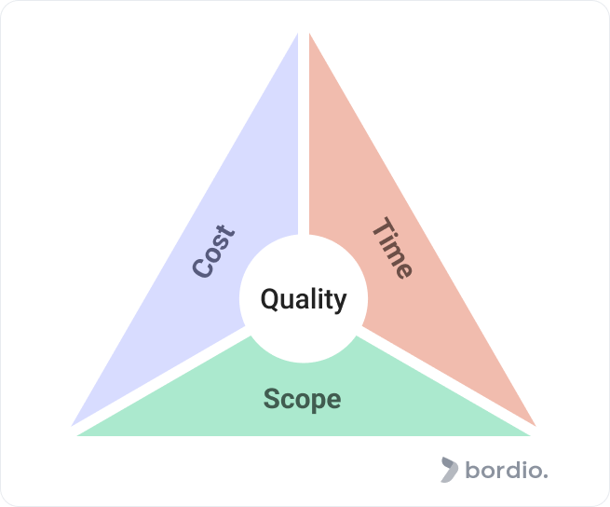
Example:
- Scenario 1: If a client wants additional features (expanded scope), the project manager either needs more time or a bigger budget.
- Scenario 2: If a project deadline is shortened, either the scope must decrease, or the budget must increase (e.g., hiring more people).

5. The S Curve in Project Management
The S Curve is a graphical representation that tracks cumulative project progress over time. Initially, progress is slow (forming the lower part of the "S"). As the project picks up pace, the curve steepens, indicating faster progress, before leveling off again as the project nears completion. It typically starts slowly, accelerates in the middle, and then levels off as the project nears completion.
Phases of the S Curve:
- Planning and Initial Work: Slow progress as planning, resource allocation, and initial steps take place.
- Ramp-Up: Major execution and task completion occur; this is the steepest part of the S curve.
- Completion: Progress slows as final tasks and closeout activities are completed.
Real-World Example:
- Example: A construction project for a new building. Initially, site preparation takes time, but once the structure starts going up, progress accelerates. As interior work begins, progress slows again, approaching completion.
The S-Curve is useful for:
- Monitoring project progress: Comparing actual progress to the planned S-Curve.
- Forecasting costs: Predicting future costs based on the S-Curve.
- Identifying potential issues: Early or late deviations from the S-Curve can signal problems.

